X-band is fine
L-band is a little low.

Q-band IFA has ripple but not B,C,D

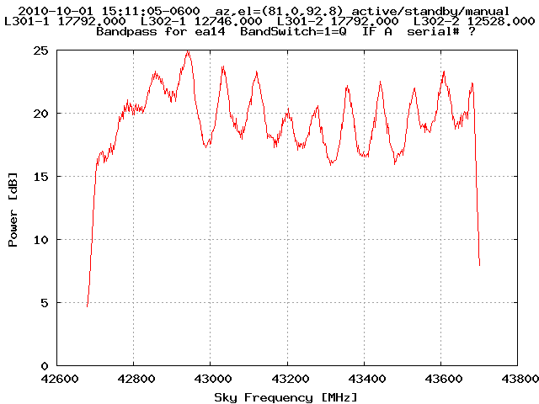

K-Band has small ripple on IFA and IFB but not C or D

