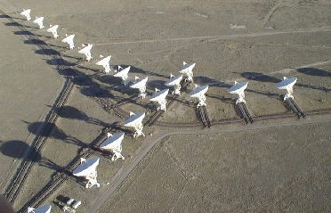


National Radio Astronomy
Observatory
PO Box O

Socorro, NM 87801

Title: Module Name Hardware Definition
Document: ? Date: 2026-07-28
Type: Revision: DRAFT

Authors: Michael Revnell

EVLA correlator CONTROLLED ACCESS plan

Michael Revnell (mrevnell@naro.edu) NRAO-Socorro

Keywords: EVLA, Correlator, Cleanliness, etc.

Author Signatures: Date:

Approved by: Date:

Released by: Date:

Change Record

Revision | Date | Author | Sections Affected | Remarks
Draft | 20070416 | D Gerrard
Draft V3 | Nov 9, 07 | S Durand | All | With Peggy Perley’s help
Draft V4 | 12/18/07 | D Gerrard | All | After meeting with SD and MR

1 Introduction

Scope:

This document sets forth the plan for limiting access to the EVLA Correlator room of the VLA central electronics building. Due to the sensitivity and expense of the equipment in the room, access inside the Correlator room will be limited to only those personnel requiring entry to perform their work.

2 The Plan

Controlled Access Procedures

- Array Operations controls access to the Correlator room. The Correlator room will remain locked at all times when the room is not occupied. Anyone wishing to obtain access to the Correlator room must sign-in with Array Operations.
- Only personnel identified in Appendix A can check out the key to have access to the Correlator room. Anyone not on the list must be accompanied by someone listed in Appendix A.
- The key will remain with the access log when the room is not occupied. Personnel must sign out the key. No duplicate keys will be issued. A back-up key will remain locked in with Array Operations key box in case the original key is lost or damaged. The individual who checks out the Correlator room key must return it.
- If the Correlator room is already occupied when another worker wishes to obtain access, the person that signed out the key is responsible for returning the key to Array Operations.
- A worker may leave the Correlator room for a short period of time (not longer than 10 minutes) and leave the room unlocked. If the absence is longer than 10 minutes, the worker should sign out and return the key.
- Cleanliness is of the utmost concern. All personnel entering the Correlator room must be clean and their tools must be clean. Work shall be completed as promptly as possible and when completed the worker shall leave and lock the room. The worker must clean up their work area.
- ESD control is also vital to the longevity of the Correlator. Do not touch on any equipment other than you own.

3 Appendix A

Correlator Room Key Checkout List

Division Heads and higher
Correlator Group
Fiber Optics Group
Electricians
HVAC Personnel
Computing Division
Emergency Response Personnel

