EVLA Acceptance Test Results

Antenna 16

Test Procedure: Version 7
October 7, 2005

Date of Test: November 4, 2005

Test Team ____Doug Gerrard__________________________
________Jerry Langevin_________Steven Durand__________
________________________________________
________________________________________

The antenna 16 Failed because the channel A down Converter was not responding when we arrived on site. After resetting the down converter the antenna passed all the other tests except for a strong birdie in X-Band channel A passband at 39.7 Mhz. This was only observed in X-Band and only in Channel A. All other Bands C, L, K and all other channels no birdies were observed.

1. Checker

- Verify the checker screen to determine if there are any errors being reported.

Purpose:
These tests verify that all of the antenna parameters are within range.

Requirements:
Complete -48V AC to DC sub-system including batteries and shunt-trip
Antenna #00 awg cable installed through cable wrap
Functional DC distribution in vertex room
All modules are within range.

Technique:
Log-on to the checker screen.

Results for Antenna :

Comments:______No checker errors were observed________________
____________________________________________________________________________________________________________________________________________________________________________________________________________________________________________________________________________________________________________________________________________________

Signature Date Antenna Passed

2. Receiver Switched Power Test

- Verify that the antenna digitizers are turned on, optical power on each of the 12 received colors is within tolerance, and that the deformatter modules in the correlator room show green LEDs lit, indicating proper sync.

- Command the antenna to the appropriate position for the intended receiver band. Using the frequency default table for each band, verify that the synthesizers are set to the proper frequencies for the intended band. (L301s and L302s)

- Verify optical power, error rate, and proper RMS values using the deformatter M&C screen. Typical RMS Range 5-10. Parity Errors should not be increasing.

Antenna IF channel | 8-Bit RMS | 8-Bit RMS | 8-Bit RMS | 8-Bit RMS
 | X-band | L-Band | C-Band | K-Band
A | 8.8 | 5.4 | 13.2 | 8.3
B | 9.3 | 6.1 | 12.4 | 10.2
C | 9.7 | 7.0 | 11.9 | 9.9
D | 9.0 | 6.2 | 11.9 | 9.0

- Connect spectrum analyzer to the T5 of each IF and verify proper bandpass level and shapes. See below for typical shape.
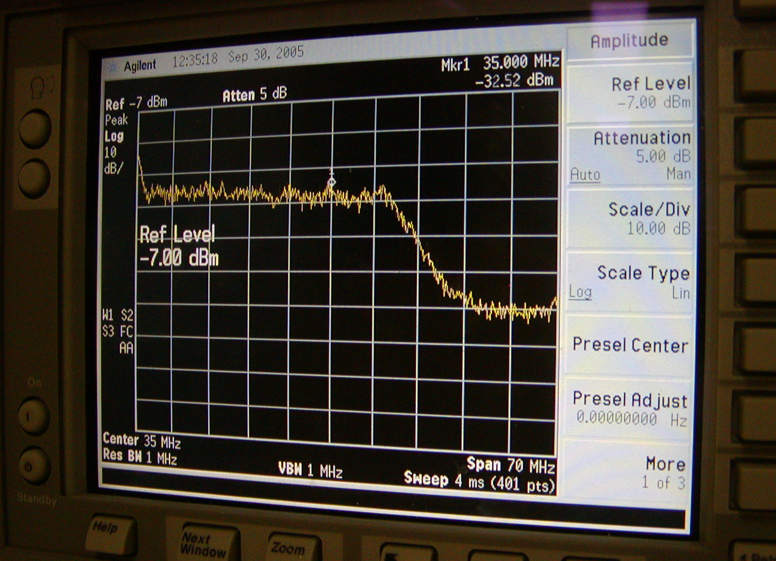

 | X Band | L-Band | C-Band | K-Band
IF A | Birdies* | ok | ok | ok
IF B | ok | ok | ok | ok
IF C | ok | ok | ok | ok
IF D | ok | ok | ok | ok
- * 39.7 MHz +10 dB and 15.6 MHz + 4dB
Connect oscilloscope to T5 ‘detector’ test jack (using VLA 9.6 Hz as trigger) and verify that switched power is present. Switched power should be in phase if antenna L305 is synchronized and out of phase if it is not. If not in phase, enable the L305 sync and verify that switched power pulls in phase with VLA 9.6 Hz. Once switched power is in phase, disable the L305 sync and verify that switched power remains stable.
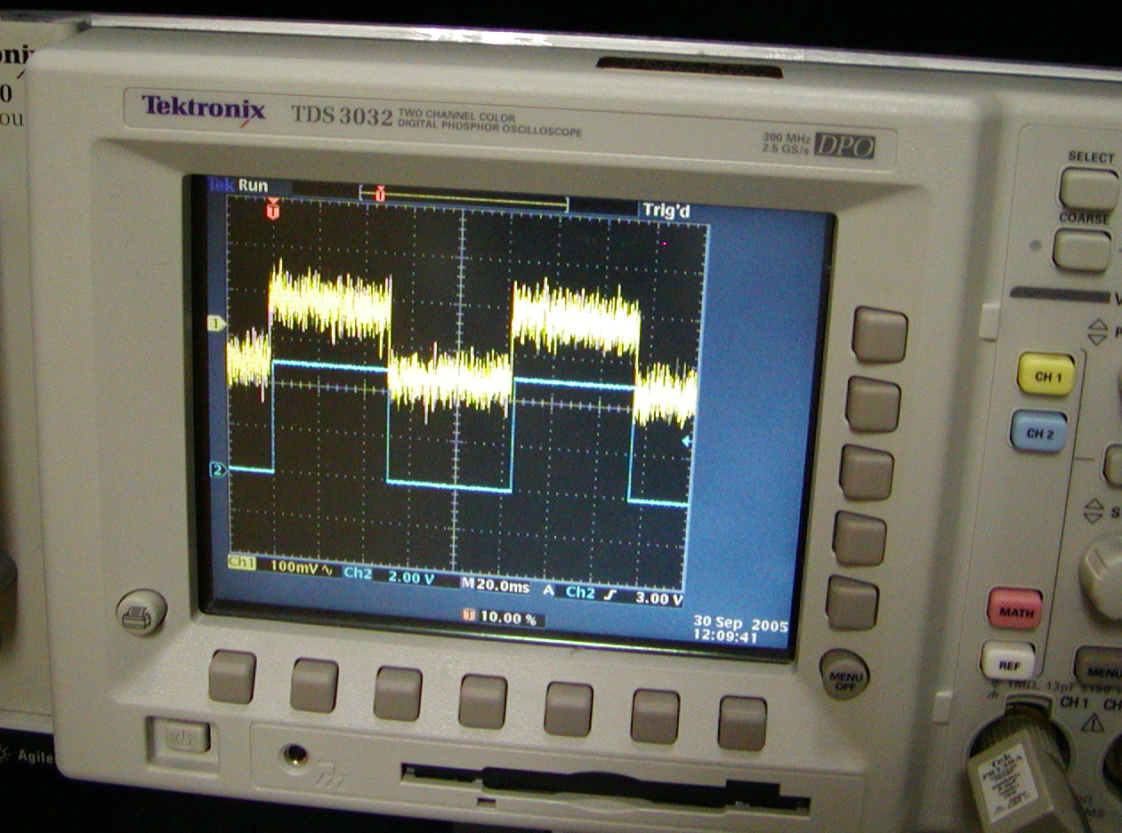

 | X Band | L-Band | C-Band | K-Band
IF A | Weak | Very noisy | OK | OK
IF B | Ok | OK | OK | OK
IF C | Ok | OK | OK | OK
IF D | noisy | OK | OK | OK

- Using the VLA Baseband overlay, verify that the T5 parameters are updating properly. By varying the attenuator in the T304s, verify that the Baseband overlay parameters change as expected.

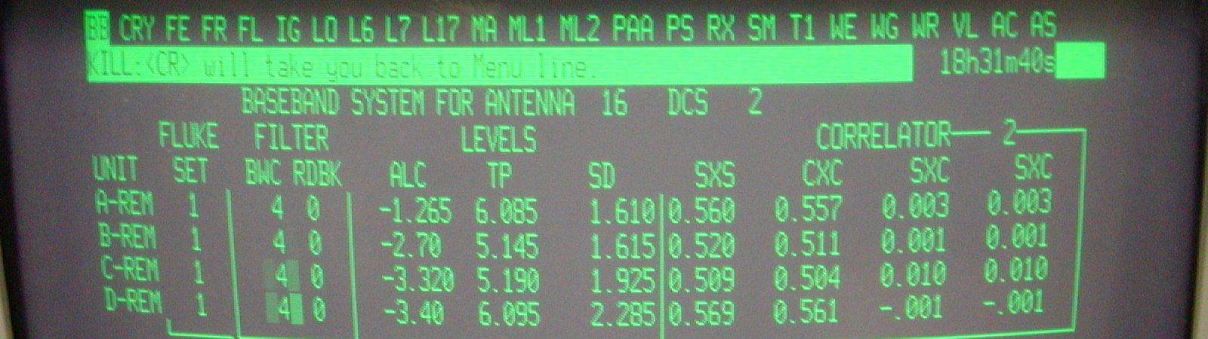

L Band | ALC | TP | SD
A | -3.1 | 5.4 | 2.8
B | -4.2 | 5.5 | 3.5
C | -4.1 | 5.9 | 3.7
D | -3.9 | 6.1 | 3.9

X Band | ALC | TP | SD
A | -4.2 | 5.9 | 1.0
B | -4.2 | 5.3 | 1.4
C | -4.4 | 5.9 | 1.4
D | -3.9 | 6.1 | 1.7

C-Band | ALC* | TP* | SD*
A | -4.3/-3.4 | 5.8/5.6 | 0.4/0.9
B | -4.5/-4.0 | 5.8/5.2 | 0.3/0.8
C | -4.5/-2.1 | 6.1/6.0 | 0.3/0.7
D | -4.3/-3.9 | 6.1/6.1 | 0.3/0.8
* Adjusted Levels manually in down Converters
From RF attenuator =18 dB & Channel 1= 10dB
To RF attenuator =18 dB & Channel 30dB

K-Band | ALC | TP | SD
A | -3.9 | 5.7 | 2.4
B | -4.4 | 5.7 | 1.3
C | -4.4 | 6.0 | 1.6
D | -4.1 | 6.0 | 1.8

 | ALC | TP | SD

 | ALC | TP | SD

Purpose:
These tests verify the function of the digitizers, the formatters, the optical link, the de-formatters (including the output of the D/A conversion), signal path through the T5, bandpass shapes, the ALC loop with the correlator, antenna synchronization with the VLA, and the ability to optimize power levels into the digitizers using the T304 attenuators. These tests give the most comprehensive status of the antenna and its ability to fringe with the VLA antennas.

Requirements:
Antenna receivers
Functional central LO rack
Functional MLO rack
IAT clock 10 sec. pulse
Complete fiber optic sub-system
Functional FE rack
Functional DTS (including DTS modules and de-formatters)
Functional T4 and T5 modules
Functional correlator
Functional M&C (with appropriate software)

Technique:
The control software will be used to configure band. During this test, the outputs of the T5 will be monitored with a spectrum analyzer and oscilloscope to verify IF signal quality. The M&C will flag and print both antenna and central monitor data that is out-of-range during these tests. The M&C will test each receiver in sequence and provide data at the conclusion of the test.

Results for Antenna :

Comments:______________________________________________________________________________________________________________________________________________________________________________________________________________________________________________________________________________________________________________________________________________________________________________________________________________________________________

Signature Date Antenna Passed
4. Round Trip Phase Stability Test

- Verify and record stability of the RTP measurement system with M&C while the antenna is parked and moving in both directions. Valid change not greater than +/- 0.0002.
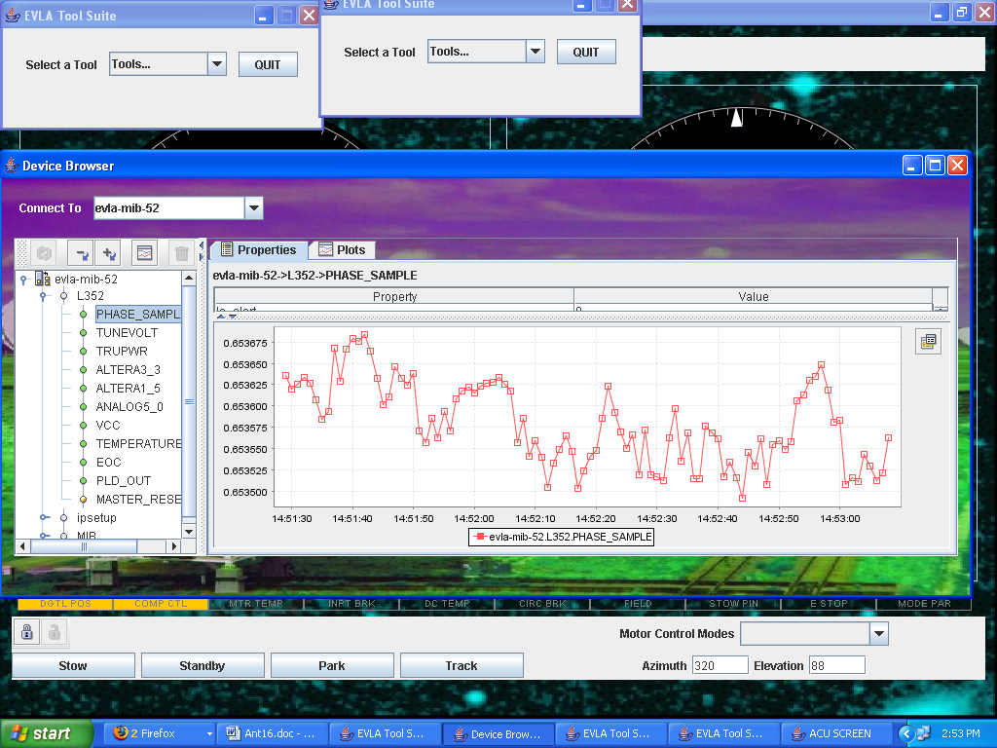

Clockwise
Counter-Clockwise
Clockwise
Counter-Clockwise

Purpose:
This test allows performance verification of the RTP hardware in both a static and dynamic state. Resolution of this test is estimated to be no better than 0.5 ps.

Requirements:
Functional Round trip LO fiber system

Technique:
Using the M&C sub-system, monitor and record RTP performance in static (non-moving) condition and then repeat the measurement as the antenna is being moved.

Results for Antenna :
Comments:______________________________________________________________________________________________________________________________________ _______________________________________________________________________________________________________________________________________________
_______________________________________________________________________

Signature Date Antenna Passed

