NATIONAL RADIO ASTRONOMY OBSERVATORY
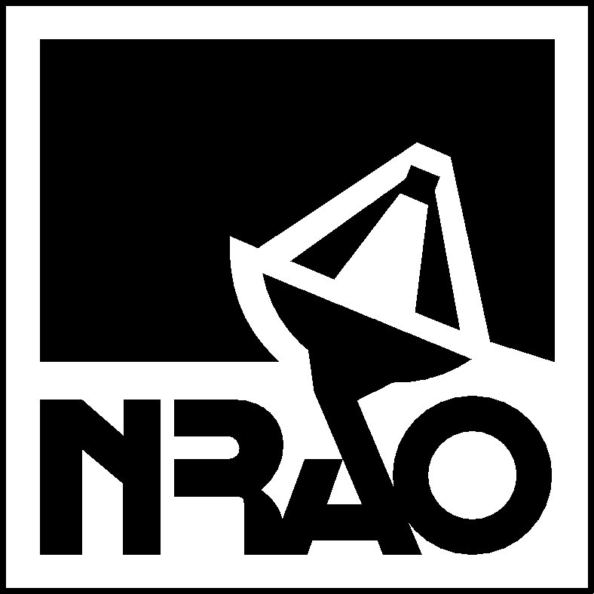
ALMA North American Project Office
2496 Old Ivy Road, SUITE 226 CHARLOTTESVILLE, VA 22903
TELEPHONE 434-296-0296 FAX 434-296-0255

MEMORANDUM

TO: North American ALMA Task Leaders
CC: JAO
FROM: Marc Rafal, Darrel Emerson
SUBJECT: Cost Review Announcement
DATE: 5th February 2003
__________________________________________________________________

During the summer and fall of 2002, ALMA IPTs were asked to review their cost estimates and update the cost model for the project. The results were tabulated in October and formed the basis of the Budget Projections that accompany the current ALMA Project Plan that will be submitted for Board approval by the JAO. Furthermore, there were requirements and technical developments not yet finalized, leading to budget uncertainty. While the projected costs of the tasks assigned to NRAO remain within the budgeted allocation, the remaining contingency at this stage of the project is uncomfortably low. The ATAC report and Director’s reviews have pointed to the possibility of improving the efficiency for several of the production tasks. Fred Lo has asked ATAC to perform a cost review across the North American portions of the ALMA project. The ATAC is charged to:

Review the basis of estimates in the existing cost model
Review the cost model for completeness
Review production plans for potential cost savings

Based on the review, the panel may make specific recommendations for:

Changes in production plans
Changes in the organization of work packages
Changes in the cost model

The ATAC will conduct interviews and meetings with each of the NA ALMA task managers and will issue a report of their recommendations to the North American Project Manager and the NRAO Director. Any revisions to production plans, task assignments and budget assumptions will be reviewed as appropriate with the JAO and European project.

